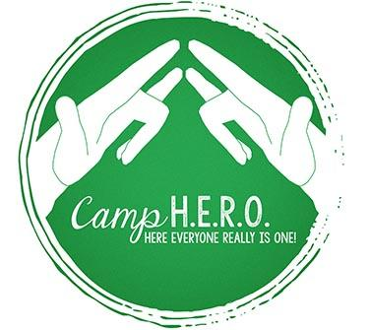

Summer Camp! To most of us, those two words evoke happy memories of cabins, sleeping bags, campfires, crafts, canoeing, hiking, and the beginning of life-long friendships. Many children and teens who are Deaf or Hard-of-Hearing have been excluded from summer-camp fun. At Camp HERO, they are able to enjoy summer camp in a beautiful, safe environment where communication barriers are removed.
Camp HERO (Here Everyone Really is One) is an annual summer week experience at Camp Victory in Millville, PA. The goal of Camp HERO is to promote the social growth, creativity, and self-confidence of Deaf/Hard of Hearing children through camp activities and access to appropriate Deaf/Hard of Hearing role models. The counselors are mainly Bloomsburg University students who have a background in working with children who are deaf or hard of hearing. Some of the staff themselves are Deaf or Hard-of-Hearing and serve as positive role models for the campers. Camp HERO can accommodate up to sixty-five campers from ages 6 to 17.
We need your help! It costs approximately $360 to send one child to Camp HERO. Many families are unable to pay the camp fee and we strive to provide scholarships for those campers. Every donation would help to provide a camp experience for deaf and hard of hearing children. Thank you for considering a gift that will touch lives.

Sincerely,

